How do I log into Clever?
- To log into the Clever Portal, go to your district’s Clever login page: https://clever.com/in/psusd
- Log in with Google. Use your district username and password. District Google Account: Sign in with your username@psusd.us (your full 13150-----@psusd.us number and your 8 digit birth date the password.)
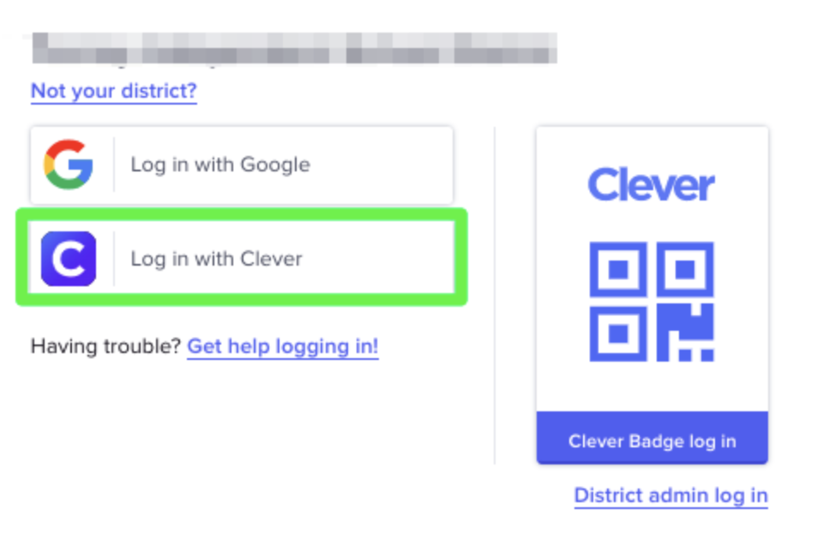
- From your Clever Portal, click on the application icon you’d like to use:
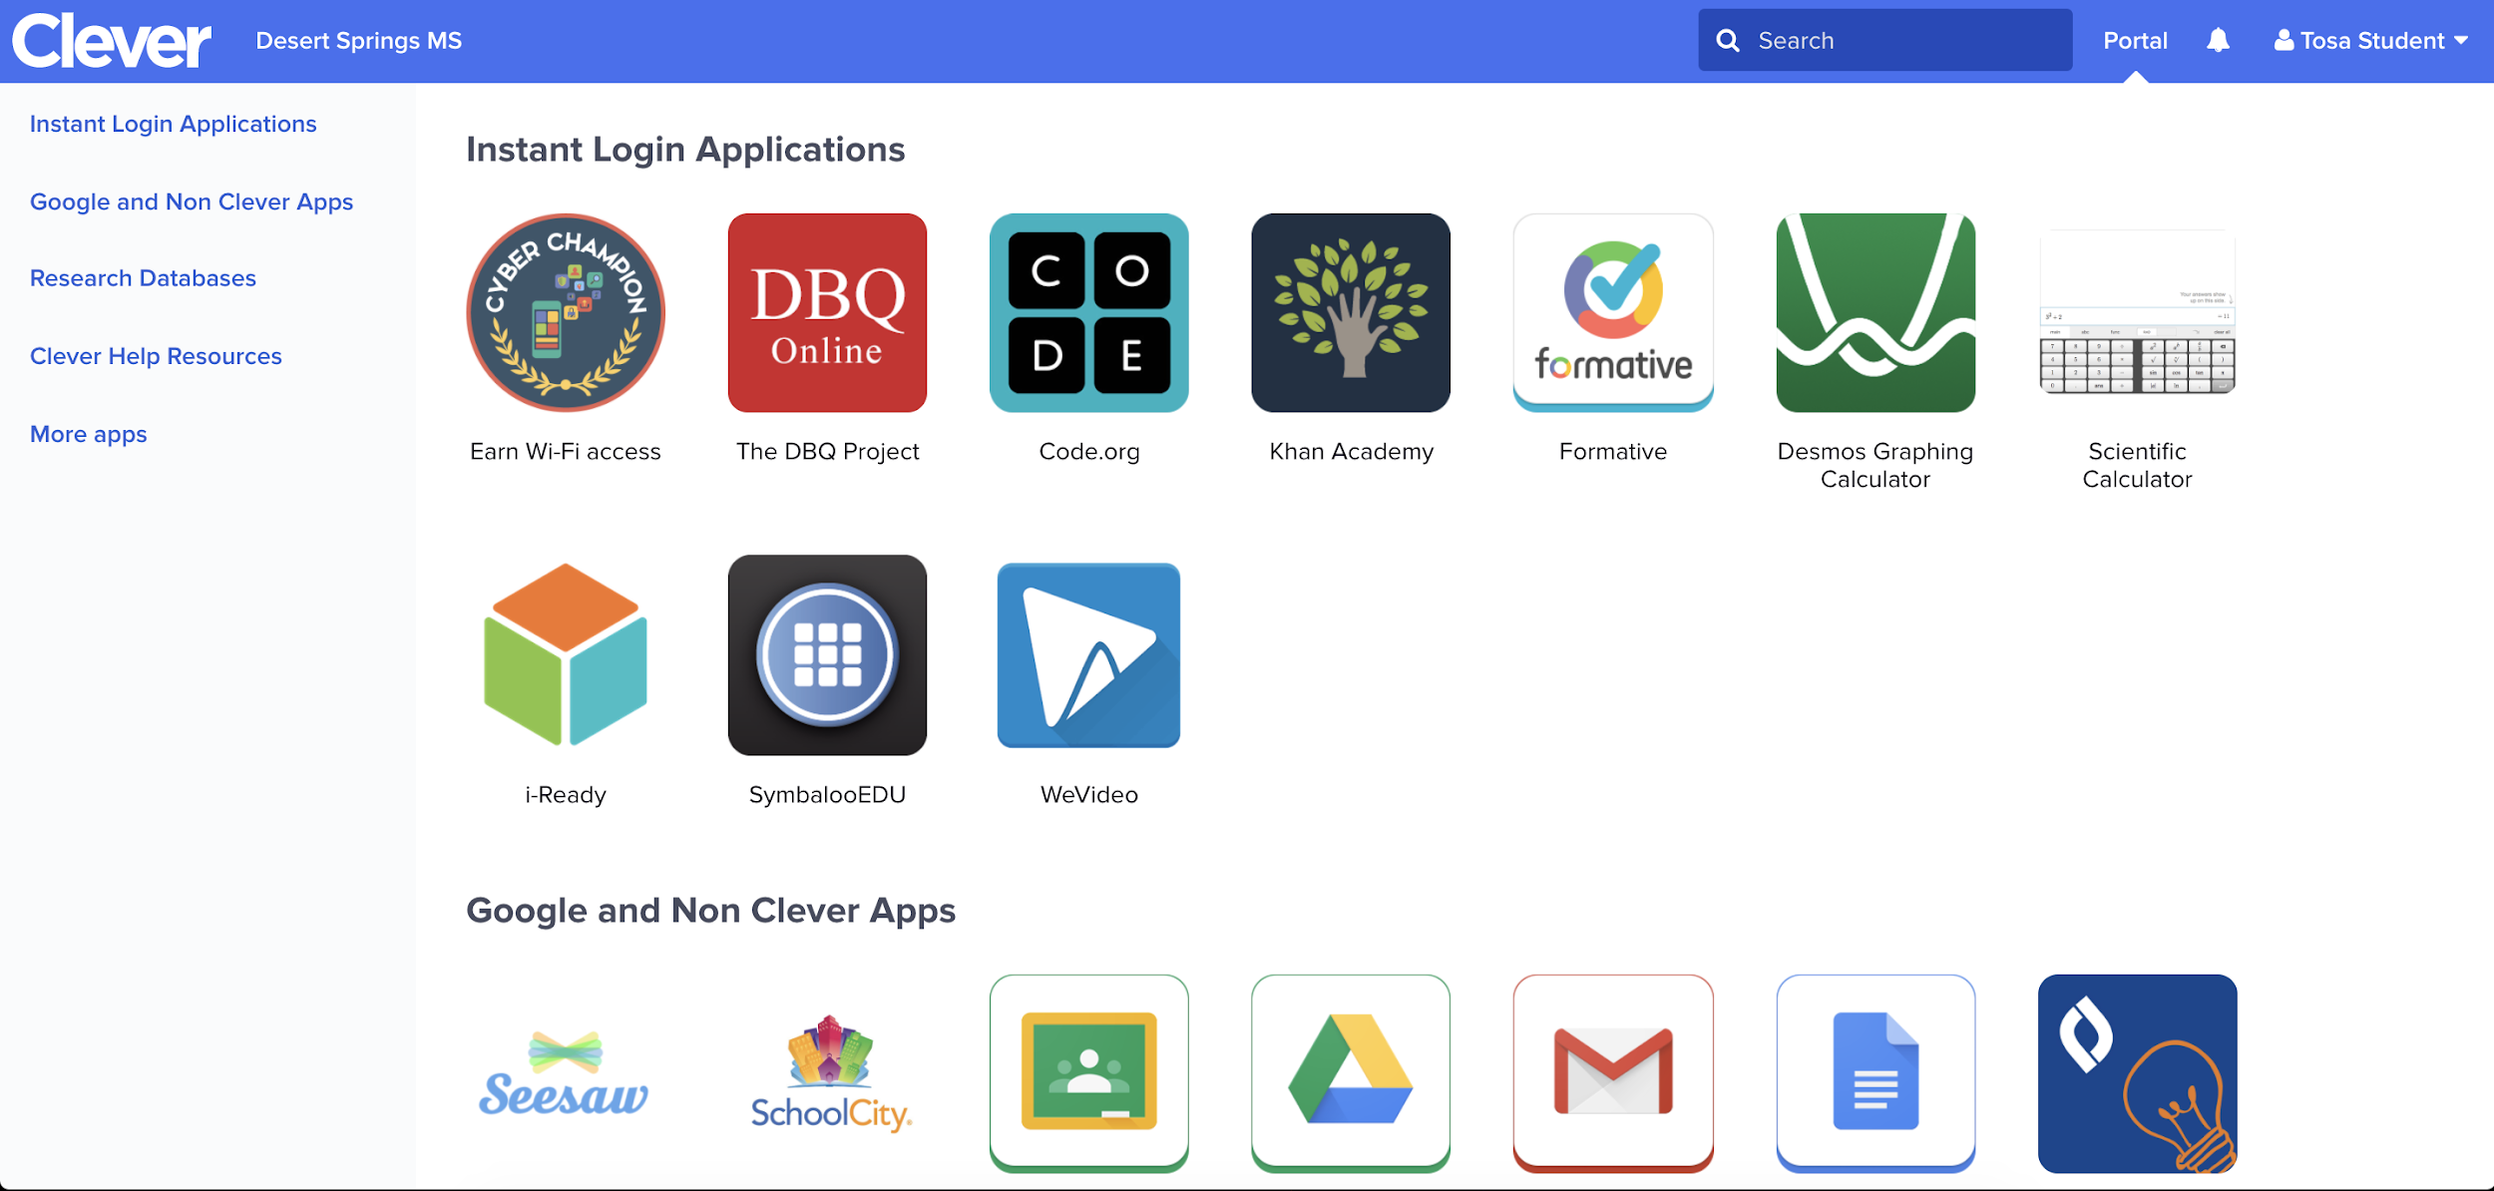
- Start working!

How do I log into Clever with a Clever Badge?
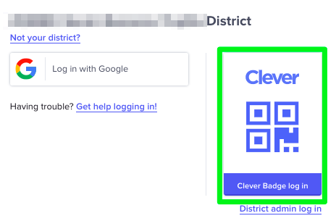
Your teacher can provide you with a Clever Badge to scan in. Please contact your teacher for help with Clever Badges.
Your browser may ask you to allow clever.com to use your computer's camera. Click 'Allow'.
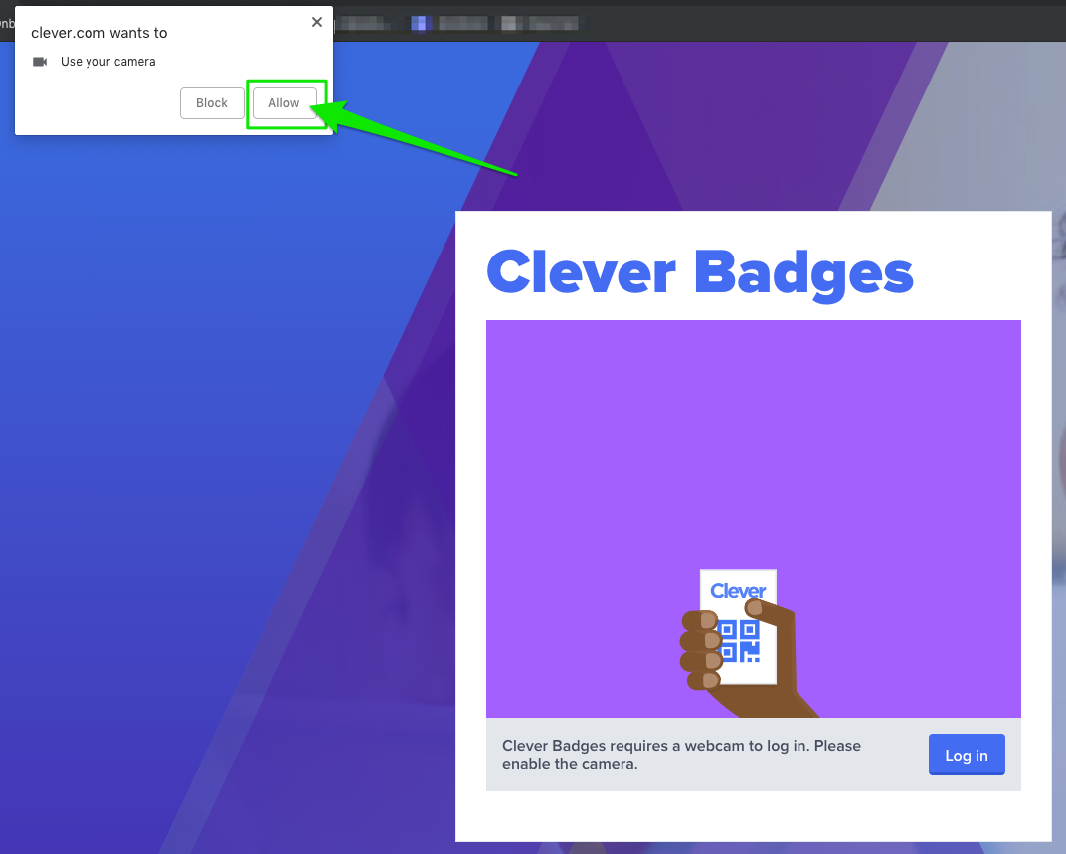

Hold your Badge up to your computer camera and wait for the green checkmark to log you into Clever!

